DSO 545 – Final Project

Mobile OS Section

1. Check the density of mobile request for a period of one year: Sep 2015 to Sep 2016

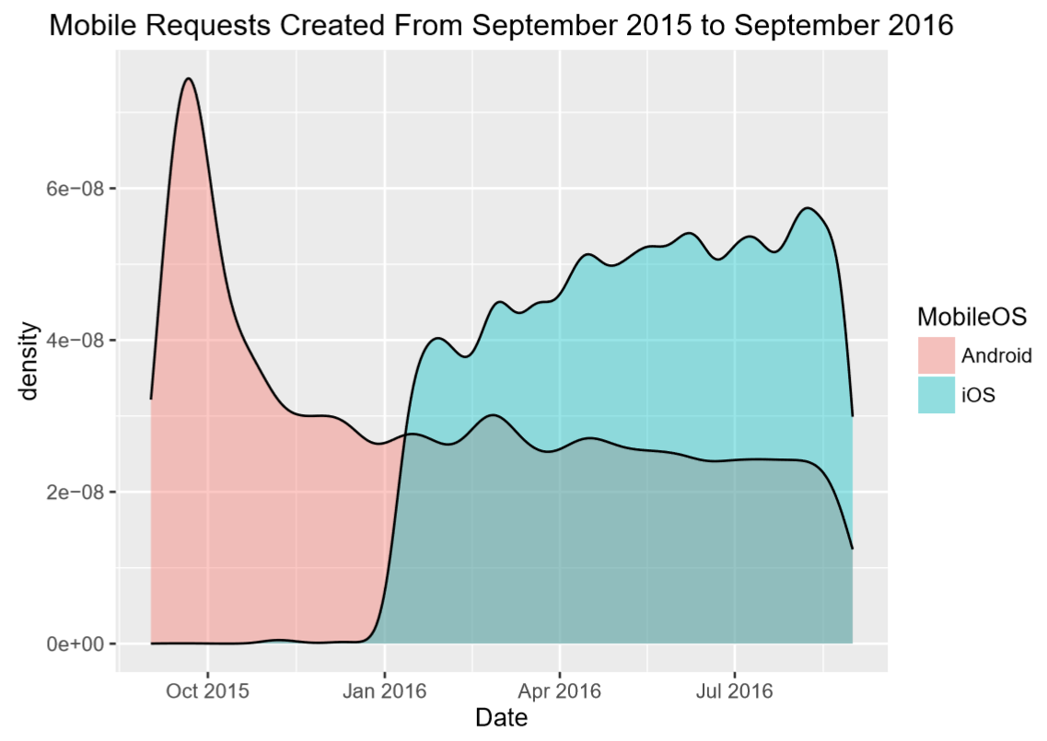

* 1. A big spike of requests on Android were made during the month of October 2015 – interesting to find out why
  2. iOS App seemed to be new and only started activity around January 2016.
  3. Since the entrance of iOS to the game, more requests were made via Apple than Android phones.

1. Check the most common requests made by the different mobile apps

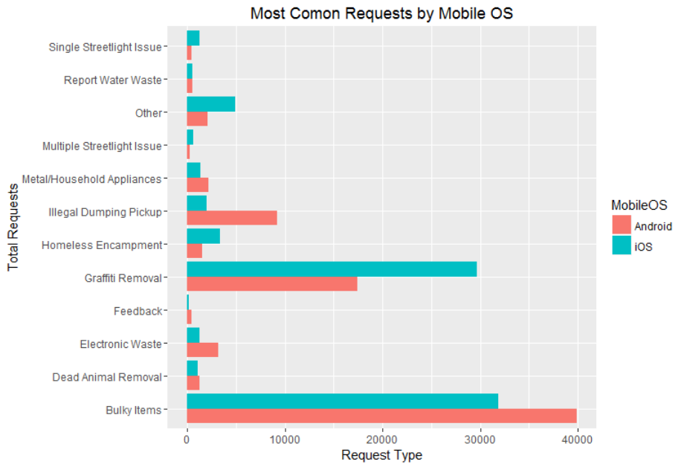

* 1. Most requested by Android (in descending order): Bulky Items, Graffiti Removal, and Illegal Dumping Pickup
  2. Most requested by iOS (in descending order): Bulky Items, Graffiti Removal, and Other
  3. Significantly more iOS users report graffiti removal.

1. Check Requests by Time and Date within the different Mobile OS:

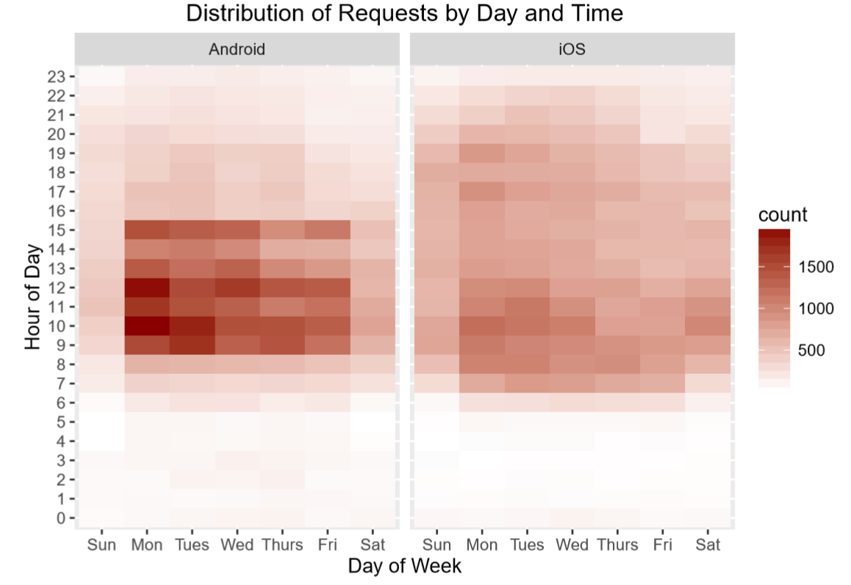

* 1. Most requests were made with Android phones.
  2. Monday is a highly busy day – More calls are made in the beginning of the week.
  3. Most requests are made between 8AM and 3PM.
  4. iOS calls go until later hours than Android – up to 9PM
  5. Barely any requests are made from midnight to 6 AM

1. Check requests that are made between midnight and 6AM: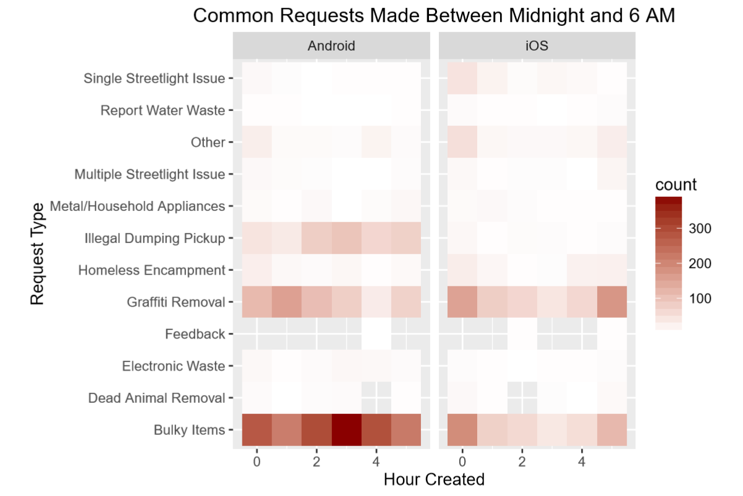
   1. Most common requests made at night: Bulky Items followed by Graﬃti Removal.
   2. More requests are made from Android at night.
   3. Requests for Illegal dumping pickups are made only via Android at night.
2. Check mobile request source on both Mobile OS:

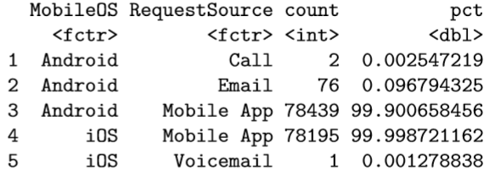

* 1. 99.9% of requests are made via the mobile app.
  2. The other sources are not enough to further explore…

1. Check Mobile Map usage in LA:

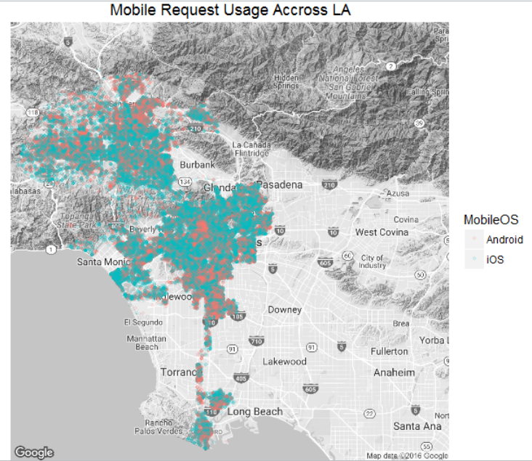

* 1. The distribution across LA seems to be fairly distributed among both OS
  2. Most calls are made in central LA area, Santa Monica, and the Valley.
  3. iOS seems to be more dominant on the map.

1. Check daily usage by Mobile OS on the LA map: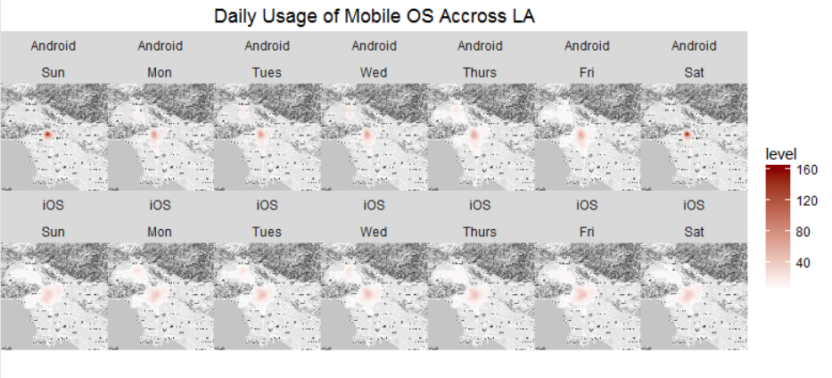
   1. Saturdays and Sundays in North Hollywood area seem to be the busiest for iOS.
   2. Not much can be told from Android.